Technical Assessment Submission: Virtual Assistant
Candidate: Johnnel Respeto
Position: Virtual Assistant
Date: July 28, 2026

1. Calendar Conflict Solution & Communication Drafts

Strategy & Logic
When facing overlapping high-priority obligations, I prioritize retaining the Investor Meeting at its original time. Investor schedules are typically rigid and often tied to critical funding or board governance, making them difficult to reschedule without risking momentum. The Key Partner Meeting is rescheduled to another open slot on the same day or early the following day, offering flexible options to minimize inconvenience while maintaining a strong relationship.

Communication Drafts
Draft A: Reschedule Request to Key Partner Subject: Rescheduling Request: Sarah Jenkins / Nexus Innovations Discussion
Dear Mark Vance,
Thank you for your continued partnership with InnovateX Solutions. Due to an unavoidable calendar conflict that has just arisen for today, we need to adjust our scheduled meeting time.
To ensure Sarah Jenkins can give your discussion her full, undivided attention, could we shift our call to one of the following times?
- Option 1: Today at 2:00 PM EST
- Option 2: Today at 4:30 PM EST
- Option 3: Tomorrow at 10:00 AM EST
Please let me know which option works best for you, and I will send an updated calendar invite immediately. Thank you for your flexibility!
Best regards,
Johnnel Respeto | Executive Assistant to Sarah Jenkins
InnovateX Solutions
Draft B: Confirmation to Investor Subject: Confirmation: Sarah Jenkins / Apex Capital Meeting Today
Dear Apex Capital Team,
I am reaching out to confirm our meeting scheduled for today at 10:00 AM EST. Sarah Jenkins and the team at InnovateX Solutions look forward to our discussion.
Please let me know if there are any specific deck materials or agenda items you would like prepared in advance. I have re-sent the calendar invite with the direct video conference link.
Best regards,
Johnnel Respeto | Executive Assistant to Sarah Jenkins
InnovateX Solutions

2. Inbox Triage System & Key Email Drafts

4-Tier Priority Categorization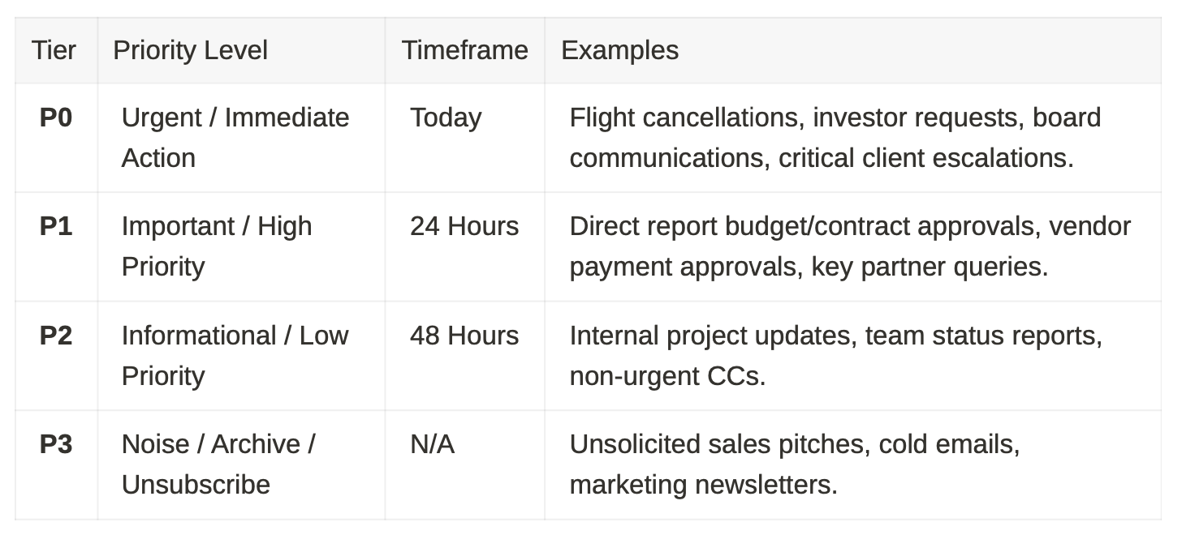

Draft Responses for 3 Key Emails
Email 1: Urgent Request from Board Member Subject: Re: Urgently Requesting Q3 Financial Overview
Dear Arthur Pendelton,
Thank you for your note. Sarah Jenkins received your request for the InnovateX Solutions Q3 Financial Overview.
I am compiling the final report alongside our finance lead now and will deliver it to your inbox by 12:00 PM EST today. Please let me know if you require any specific breakdown ahead of time.
Best regards,
Johnnel Respeto | Executive Assistant to Sarah Jenkins
InnovateX Solutions
Email 2: Direct Report Requesting Budget Approval Subject: Re: Approval Needed: Marketing Campaign Spend
Hi David Miller,
Thank you for bringing this to our attention. I have added this budget review to Sarah Jenkins’s high-priority administrative block for today at 1:00 PM.
You can expect a sign-off or feedback by 2:00 PM EST. I will keep you posted on any updates.
Best,
Johnnel Respeto | Executive Assistant to Sarah Jenkins
InnovateX Solutions
Email 3: Cold Vendor Pitch Subject: Re: Demo Request - Operational Software Solutions
Dear Tech Flow Solutions Team,
Thank you for reaching out to InnovateX Solutions. Sarah Jenkins’s schedule is currently fully committed to internal strategic initiatives.
If you would like to share a 1-page overview deck, I will gladly keep it on file for future reference should a relevant need arise.
Sincerely,
Johnnel Respeto | Executive Assistant to Sarah Jenkins
InnovateX Solutions

3. Revised Travel Plan & Contingencies

Immediate Action Plan
- Primary Carrier Rebooking: Contact airline desk or VIP support to rebook on the next available direct flight departing early tomorrow morning.
- Alternative Carrier Routing: Reserve seats on a rival airline operating a similar route to guarantee arrival at least 3 hours before the event.
- Ground/Rail Options: If the destination is within 4–5 hours, secure an express train or private driver service as a reliable backup.

Revised Itinerary Summary
- Current Status: Original Flight #123 Canceled.
- New Flight Route: Flight #456 departing tomorrow at 6:30 AM, arriving at 9:00 AM (Event starts at 11:30AM).
- Ground Logistics: Private chauffeur booked for 5:00 AM residence pickup and 9:15 AM airport departure direct to event venue.
- Contingency: Secondary flight reserved for 8:00 AM. If both flights face delays, virtual participation AV setup at the venue is pre-arranged as a fall back.

4. Daily Workflow System (Overload Prevention)
- 08:00 AM – 08:30 AM | Morning Inbox Sweep: Triage unread emails into P0–P3 folders. Resolve critical operational issues (travel/scheduling disruptions).
- 08:30 AM – 08:45 AM | Executive Alignment Sync: 10-minute daily standup to align on top 3 priorities, daily calendar, and urgent decisions.
- Protected Focus Blocks: Implement two 60-minute “Executive Deep Work” windows (no calls/meetings) for core work and inbox clearing.
- 05:00 PM – 05:30 PM | Daily Wrap-Up: Clear remaining P1 emails, review tomorrow’s schedule, re-confirm travel logistics, and issue an End-of-Day Executive Briefing.

5. Executive Update Summary
EXECUTIVE BRIEFING — 8:30 AM UPDATE
- Travel Urgent: Your flight tomorrow was canceled. I have rebooked you on Flight #456 departing at 6:30AM tomorrow (arriving 9:00 AM, well ahead of your 11:30 AM event). Private driver confirmed for a 5:00AM pickup.
- Calendar Conflict: Investor meeting with Apex Capital is locked in for 10:00 AM EST today. Key Partner meeting with Mark Vance (Nexus Innovations) was moved to 2:00 PM EST to avoid overlap (confirmation pending).
- Action Required from You:
  - Approve David Miller’s Marketing Budget request (flagged in draft folder for 1-click review).
  - Review 3-bullet briefing note for today’s investor call with Apex Capital.

Bonus Challenge: Decision Justification & Improvement

Decision Justification
I prioritized retaining the investor meeting at its original time because investor availability often involves multiple external stakeholders with rigid schedules, where rescheduling risks losing critical funding momentum. In contrast, key partner relationships typically offer greater flexibility for same-day or next-day adjustments without jeopardizing trust, provided communication is transparent and prompt.
My immediate goal was to protect critical business capital while maintaining active partner dialogue. However, I recognize that internal or partner negotiations may hold immediate operational urgency that overrides standard protocols. I handled the reschedule with direct, high-touch communication to preserve partner goodwill, but I understand that without a pre-established prioritization framework, this decision did not alignwith your specific preference for this instance.

Systemic Improvement to Executive Alignment
To ensure 100% alignment moving forward, I will establish an Executive Decision Matrix & Priority Playbook. This living document will explicitly rank stakeholders (e.g., Tier 1: Board/Investors, Tier 2: Revenue Partners, Tier 3: Internal Leads) and define clear rules of engagement for emergency rescheduling, travel thresholds, and inbox delegation preferences.

